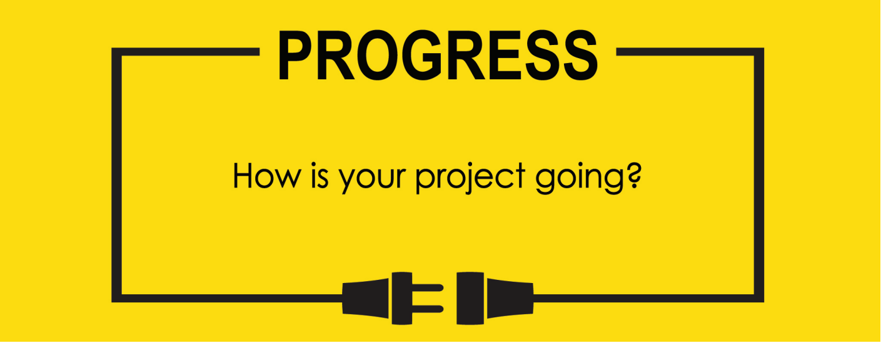

**Name: Zach Wilcox**

**Project Title: GreenBox**

**Previous Goals**

What were your three goals from last week? Were you able to complete them? If so, select Completed. If not, select the level of completion and explain in the Notes section why the goal was not completed, what still remains to be done, and when you expect to finish work on the goal.

Goal #1 from last week: Finish box build

**Status:** _____Completed __x___Partially Completed _____No Progress

**Notes:**

A previously assembled portion of the box was damaged when being moved, so another piece of acrylic had to be purchased to replace the damaged portion. The new piece has been shaped but not yet welded to the other parts of the box. Some of the holes between the two chambers have been cut out, but still need some sanding.

Goal #2 Finish input/output software

**Status:** _____Completed __x___Partially Completed _____No Progress

**Notes:**

The output portions of the code and the timers are functioning as planned. However, during debugging, it was found that the input portion of the code acts inconsistently when run for longer periods. I currently suspect a timing error in reading from the sensor, but that is just a guess at this point.

Goal #3 Test input/output software

**Status:** _____Completed __x___Partially Completed _____No Progress

**Notes:**

Debugging has been going well. Output portions of code have been verified, and some bugs on the sensor input have been discovered. With any luck, those portions will be all smoothed out by next week.

**Next Three Goals**

Choose three subtasks from your Gantt chart and use them to form goals that you plan to complete this week. In the text box beneath each goal, give details about what you plan to accomplish. Include details such as what materials are needed, how many hours each day you plan to devote to the task, and so on.

NOTE: THESE ARE INDIVIDUAL GOALS THAT YOU PLAN TO ACCOMPLISH. THESE ARE NOT TEAM GOALS.

**Goal #1:** Finish box build

**Goal #2:** Finish input/output software

**Goal #3:** Solder together the circuits that are known to be working correctly

🡨--------- Code starts acting up in here after a while

🡨-------- Might be issues with my delay here?

Another theory is that I messed something up with my timer clock speeds, so I will go recheck that as well.

Gantt Chart has not changed

